CEF Sustainability Leadership Development Program 2018
“Meeting Sustainability Challenges with Transformational Leadership”

Mashpi Forest, Ecuador
November 4-10, 2018

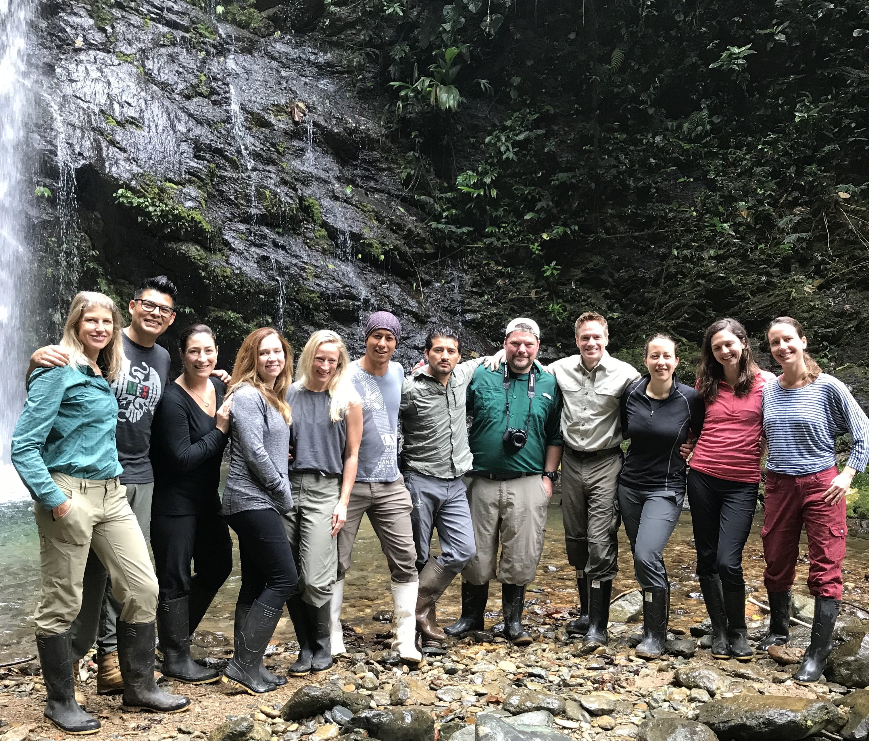

To submit your application:

- Complete the Candidate Information Section below
- List two supporting references below and ask them to complete this very brief online recommendation form: https://www.surveymonkey.com/r/8M9W836
- Complete an essay of less than 500 words
- Include a resume/CV
- Email this information to devon@corporateecoforum.com by August 15, 2018

Background:

Each year, CEF selects a small group of standout employees from member companies to join a once-in-a-lifetime leadership development program built around a theme that is intended to inspire, educate and empower emerging corporate sustainability leaders. Previous programs have included trips to Yellowstone National Park, Patagonia National Park, Chiapas, Idaho’s Salmon River, the Amazon, and Antarctica, each led by renowned experts in sustainability, conservation and business leadership.

CEF’s 2018 Leadership Development Program will focus on the theme, “Meeting Sustainability Challenges with Transformational Leadership.”

Transformational Leadership has been defined as a process where "leaders and their followers raise one another to higher levels of morality and motivation" and where people are inspired to “reach for the improbable.” During the week-long program, attendees will grapple with questions like:

- How can leaders become better champions for sustainability internally?
- How can leaders ramp up engagement with existing “green teams” and other ranks of interested employees?
- How can they be more effective in driving sustainability into the fabric/DNA of companies and everyday thinking/practice of employees?
- How can leaders help create new openings for conversation and engagement with skeptics, the disinterested, or the discouraged?
- How can leaders stay resilient and energized for the long-term?
The program will be led by a transformational leader in his own right, Rob Bernard, CEF Leadership Council Member and Chief Environmental Strategist at Microsoft, along with Julia Novy-Hildesley, Professor of the Practice and Executive Director of Stanford's Change Leadership for Sustainability Program and renowned National Geographic experts, connected to the program’s base for the week, Mashpi Lodge.

Location:
Mashpi Lodge is one of National Geographic’s “Unique Lodges of the World” — an unparalleled place to gain inspiration from the resilience and diversity of the surrounding ecosystems. Though only a short drive from Quito, the capital of Ecuador, the lodge is perched at more than 3,000 above sea level between lower montane rainforest and cloud forests, situated in the Chocó biogeographical region, which runs north-south from Panama, Colombia, Ecuador and Peru. It encompasses the biodiversity hotspot known as the Tumbes-Chocó-Darién, extending along the western foothills of the Andes. It is considered to be of “high interest for the global conservation of biodiversity”. This is also the first forest to be considered a “Model Forest” in Ecuador. Worldwide, there are only 28 of these hotspots, spread over 164 countries.

CEF will cover the cost of a round-trip economy flight from North American airports to Quito, as well as food, accommodations, and transportation during the trip. Participants are responsible for any incidental expenses. Applications are due by August 15.

Criteria:

Candidates for this program must be employed by a CEF member company (see list), and should be:

- At an inflection point in careers with regard to sustainability—i.e., they are ready and eager to take their sustainability leadership to the next level within their organizations
- Accomplished in setting ambitious goals and getting results
- A strong team player
- Comfortable with a rigorous travel schedule and able to participate in physical activities

To Apply:
Please complete the application on this page and return by August 15.

I. CANDIDATE INFORMATION

Mr. ☐ Ms. ☐
Name:
Company:
Title:
Phone:
Email:

Accommodations at the Lodge are limited and most require sharing a room. If you would require a private room, please let us know. Otherwise, please confirm that you are willing to share a room with one or more others.

II. SUPPORTING REFERENCES
Please note: supporting references must complete this very brief online recommendation form by August 15, 2018: https://www.surveymonkey.com/r/8M9W836

Please provide the names and contact information for 1 or 2 individuals at your organization who support your candidacy and would be willing to serve as a reference if you are selected as a finalist:

Name:
Title:
Phone:
Email:

Name:
Title:
Phone:
Email:

III. ESSAY
Please note: the jury will not consider essays longer than 500 words

Please write an essay that helps the jury to understand:
- What motivates you to participate in this leadership program?
- What personal/professional experiences have prepared you to seize this opportunity?
- Why does the 2018 program theme of “Meeting Sustainability Challenges with Transformational Leadership” resonate with you?
- Describe a sustainability challenge you are currently facing, and how this issue would lend itself to group discussion and solution brainstorming during the leadership program.
- Describe how you plan to translate what you learn to action upon returning from this transformative trip.
- Feel free to include any other additional information that would help the jury to assess your candidacy.

Please type/paste your response below:

IV. INCLUDE A RESUME/CV WITH THIS APPLICATION

