CEF Sustainability Leadership Development Program 2019
“Harnessing Collaborative Leadership to Achieve Sustainability at Scale”

Peruvian Amazon
November 16-23, 2019

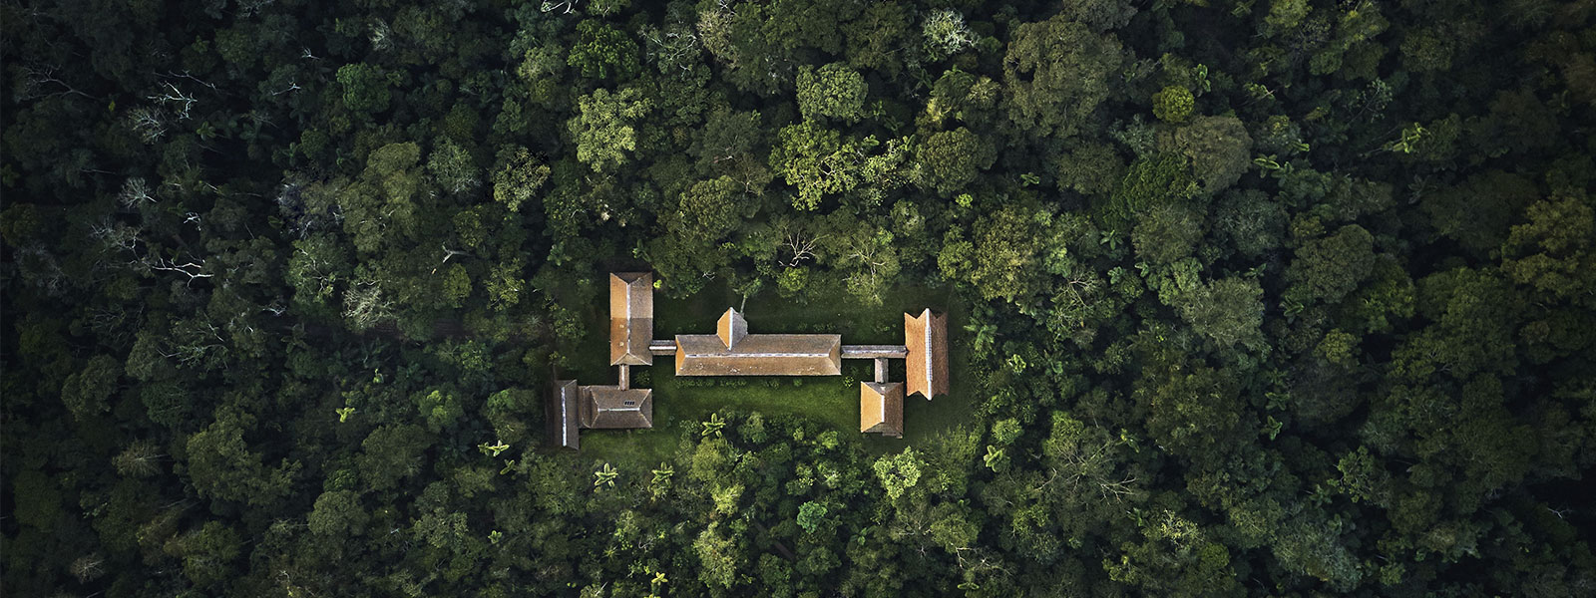

To submit your application:

- Complete the Candidate Information Section below
- List two supporting references below and ask them to complete this very brief online recommendation form: https://www.surveymonkey.com/r/3597BKP
- Complete an essay of less than 500 words
- Include a resume/CV
- Email this information to devon@corporateecoforum.com by July 26, 2019

Background:

Each year, CEF selects a small group of standout employees from member companies to join a once-in-a-lifetime leadership development program built around a theme that is intended to inspire, educate and empower emerging corporate sustainability leaders. Previous programs have included trips to Mashpi Forest, Yellowstone National Park, Patagonia National Park, Chiapas, Idaho’s Salmon River, the Amazon, and Antarctica, each led by renowned experts in sustainability, conservation and business leadership.

CEF’s 2019 Leadership Development Program will focus on the theme, “Harnessing Collaborative Leadership to Achieve Sustainability at Scale.”

In their 2018 report, Private Sector Collaboration for Sustainable Development, Rockefeller Foundation & BSR describe the need for “new leadership constellations” to meet the profound and compounding system challenges society faces, including the catastrophic impacts of climate change, increasing inequalities and social instability. Alongside this, leaders must contend with “the rapid emergence of new technologies that disrupt societies and raise new, fundamental ethical questions” such as AI.

As business leaders look to the UN’s Sustainable Development Goals (SDGs) and the Paris Agreement on climate change as guideposts, there is an increasing need to cultivate leaders with the courage to think beyond the next quarter’s report and their own four walls, to “mobilize, leverage, and direct the transformative power of business’ collective resources and capabilities to create shared solutions to global challenges.”

During this week-long Sustainability Leadership Development Program in the Peruvian Amazon, participants will immerse themselves in an awe-inspiring environment, rich with examples of planetary interconnectedness and resilience, and will establish the bonds of a powerful new peer network. They will gain insights on transformational leadership, learn effective strategies for collaboration, and be encouraged to workshop bold new ideas for collaboration that could truly move the needle on entrenched challenges. Discussions will grapple with questions like:
- What challenges stand in the way of effective collaboration? What special leadership skills are necessary to enable collaboration to work?
- What are the most promising opportunities for companies to collaborate in new ways, across sectors?
- How can leaders cultivate a corporate culture that supports effective collaboration?
- How can leaders stay resilient and energized for the long-term?

The program will be led by Bruno Sarda, President, North America, CDP and CEF Advisory Board Member and Julia Novy-Hildesley, Professor of the Practice and Executive Director of Stanford's Change Leadership for Sustainability Program.

CEF will cover the cost of a round-trip economy flight from North American airports to Lima, as well as food, accommodations, and transportation during the trip. Participants are responsible for any incidental expenses. Applications are due by July 26.

Criteria:

Candidates for this program must be employed by a CEF member company (see list), and should be:

- At an inflection point in careers with regard to sustainability—i.e., they are ready and eager to take their sustainability leadership to the next level within their organizations
- Accomplished in setting ambitious goals and getting results
- A strong team player
- Comfortable with a rigorous travel schedule and able to participate in physical activities

To Apply:
Please complete the application on this page and return by July 26.

I. CANDIDATE INFORMATION

Mr. ☐ Ms. ☐
Name:
Company:
Title:
Phone:
Email:

Accommodations at the Lodge are limited and most require sharing a room. If you would require a private room, please let us know. Otherwise, please confirm that you are willing to share a room with one or more others.

II. SUPPORTING REFERENCES
Please note: supporting references must complete this very brief online recommendation form by July 26, 2019: https://www.surveymonkey.com/r/3597BKP

Please provide the names and contact information for 1 or 2 individuals at your organization who support your candidacy and would be willing to serve as a reference if you are selected as a finalist:

Name:
Title:
Phone:
Email:

Name:
Title:
Phone:
Email:

III. ESSAY
Please note: the jury will not consider essays longer than 500 words

Please write an essay that helps the jury to understand:
- What motivates you to participate in this leadership program?
- What personal/professional experiences have prepared you to seize this opportunity?
- Why does the 2019 program theme of “Harnessing Collaborative Leadership to Achieve Sustainability at Scale” resonate with you?
- Describe a sustainability challenge that you believe would be best addressed through a collaborative solution, or a “dream collaboration” idea you have that would lend itself to group discussion and solution brainstorming during the leadership program.
- Describe how you plan to translate what you learn to action upon returning from this transformative trip.
- Feel free to include any other additional information that would help the jury to assess your candidacy.

Please type/paste your response below:

IV. INCLUDE A RESUME/CV WITH THIS APPLICATION

